**WEEK – 11**

**1#** Write an interactive program in C to store the record of the N students of a class and print them. The record consists of Name, Class, Roll No, Enrolment, Marks.

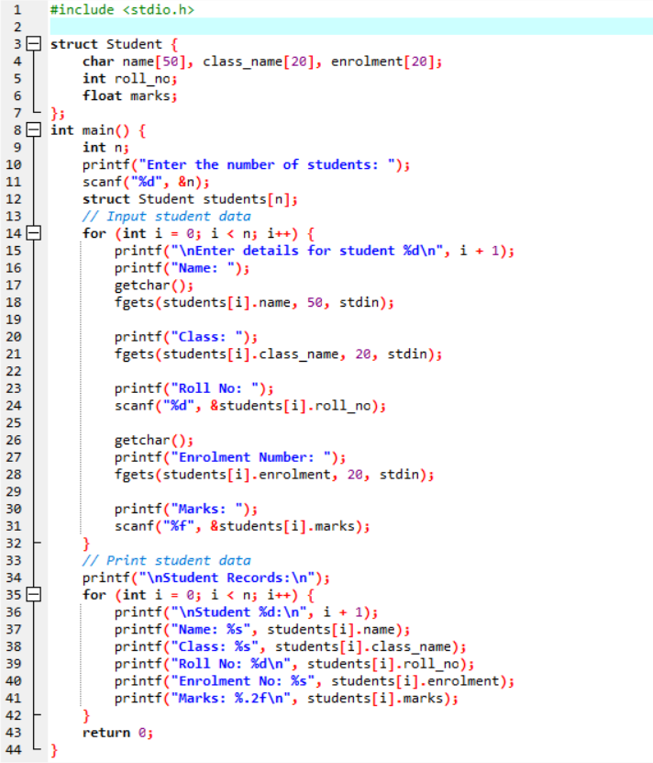

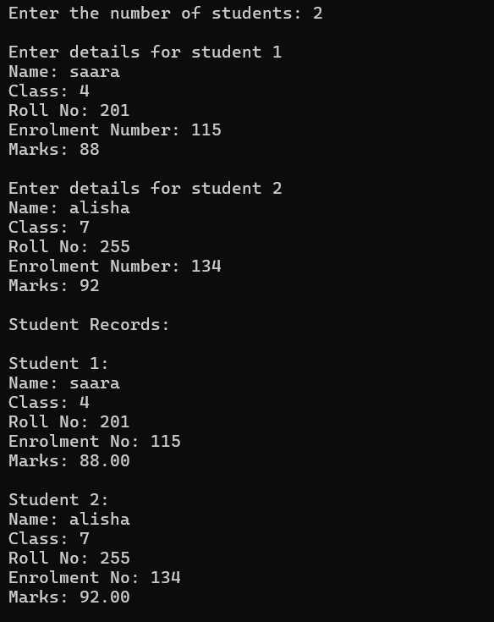

**2#** Write an interactive program in C to store the record of the N students of a class and arrange them rank wise. The record consists of Name, Roll no, Marks.

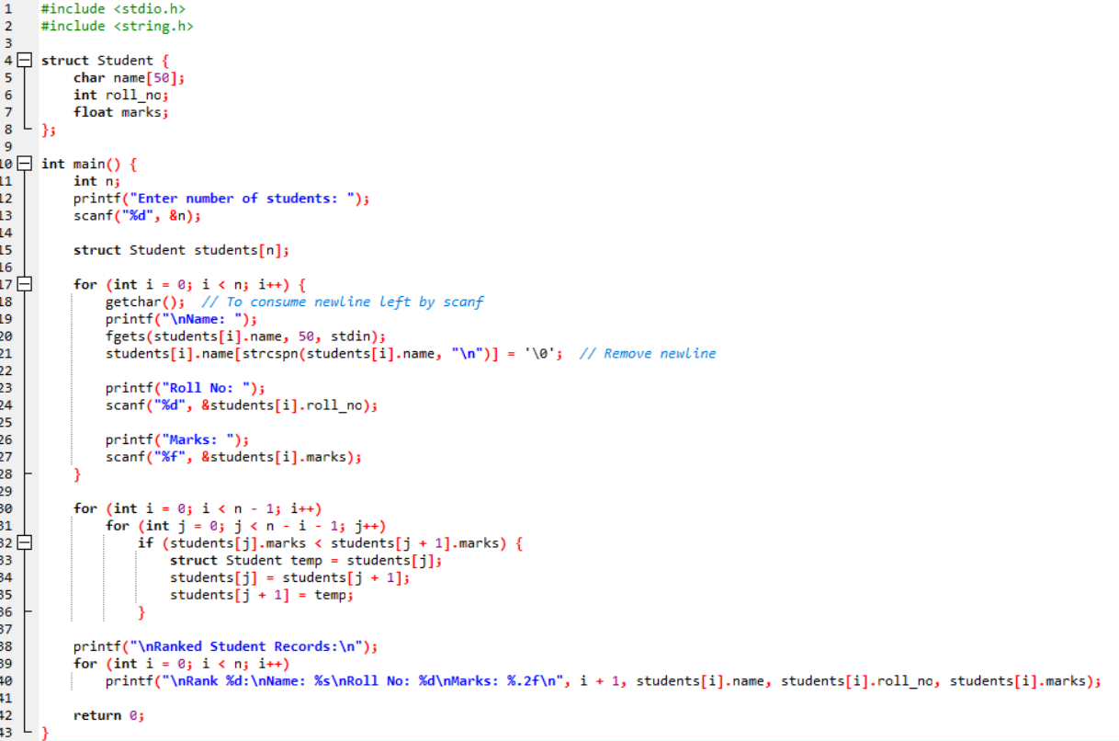

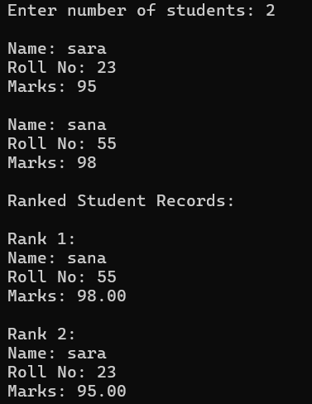

**3#** Write a C program to add two distances entered by user. Measurement of distance should be in inch and feet. (Note: 12 inches = 1 foot). Use the concept of structure.

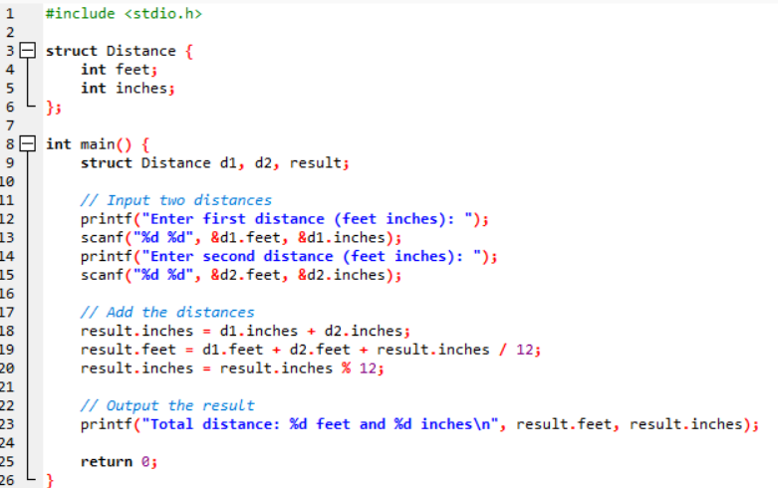

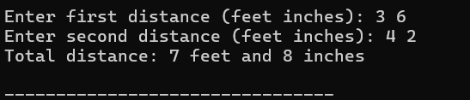

**4#** Write a Program to accept five records of employee. The Structure is:

struct {   
 char name [25];   
 int age;   
 int Basic;   
 }   
Calculate the total salary of employees as:   
Total Salary = Basic + DA + HRA   
DA = 10% of Basic   
HRA = 5% of Basic   
Display the name, age and total salary of the employees in descending order on the basis of total salary.

